Q1
INCLUDE Irvine32.inc

.data
Str1 BYTE "127&j~3#^&*#*#45^", 0

.code
main PROC

call Scan_String
call WriteInt
call CrLf

INVOKE ExitProcess, 0

main ENDP

Scan_String PROC

mov esi, OFFSET Str1
mov ecx, 0

ScanLoop:
mov al, [esi]
cmp al, 0
je NotFound

cmp al, '#'
je Found

inc esi
inc ecx
jmp ScanLoop

Found:
mov eax, ecx
ret

NotFound:
mov eax, -1
ret

Scan_String ENDP

END main
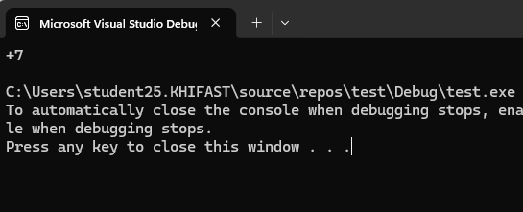
Q2
INCLUDE Irvine32.inc

.data
StrA BYTE "127&j~3#^&*#*#45^",0

.code
main PROC

push '#'
push OFFSET StrA
call Scan_String_2

call WriteInt
call Crlf

exit
main ENDP

Scan_String_2 PROC
push ebp
mov ebp, esp

mov esi, [ebp+8]
mov bl, [ebp+12]

xor eax, eax

SearchLoop2:
mov dl, [esi]
cmp dl, 0
je NotFound2

cmp dl, bl
je Found2

inc esi
inc eax
jmp SearchLoop2

NotFound2:
mov eax, -1

Found2:
pop ebp
ret 8
Scan_String_2 ENDP

END main
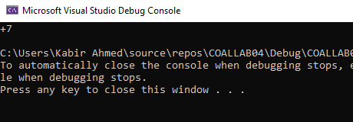
Q3
INCLUDE Irvine32.inc

.data
str1 BYTE "Hello World", 0
str2 BYTE "Fatima", 0
str3 BYTE "Hello World", 0

msg12 BYTE "Comparing 1 and 2: ", 0
msg13 BYTE "Comparing 1 and 3: ", 0
msg23 BYTE "Comparing 2 and 3: ", 0

msgEq BYTE "Strings are equal", 0
msgNe BYTE "Strings are not equal", 0

.code
main PROC

mov edx, OFFSET msg12
call WriteString

push OFFSET str2
push OFFSET str1
call IsCompare

cmp eax, 0
je showEq1
mov edx, OFFSET msgNe
jmp showMsg1

showEq1:
mov edx, OFFSET msgEq

showMsg1:
call WriteString
call Crlf

mov edx, OFFSET msg13
call WriteString

push OFFSET str3
push OFFSET str1
call IsCompare

cmp eax, 0
je showEq2
mov edx, OFFSET msgNe
jmp showMsg2

showEq2:
mov edx, OFFSET msgEq

showMsg2:
call WriteString
call Crlf

mov edx, OFFSET msg23
call WriteString

push OFFSET str3
push OFFSET str2
call IsCompare

cmp eax, 0
je showEq3
mov edx, OFFSET msgNe
jmp showMsg3

showEq3:
mov edx, OFFSET msgEq

showMsg3:
call WriteString
call Crlf

exit
main ENDP

IsCompare PROC
push ebp
mov ebp, esp

mov esi, [ebp+8]
mov edi, [ebp+12]

CompareLoop:
mov al, [esi]
mov bl, [edi]

cmp al, bl
jne NotEqual

cmp al, 0
je Equal

inc esi
inc edi
jmp CompareLoop

Equal:
xor eax, eax
jmp Finish

NotEqual:
mov eax, 1

Finish:
pop ebp
ret 8
IsCompare ENDP

END main

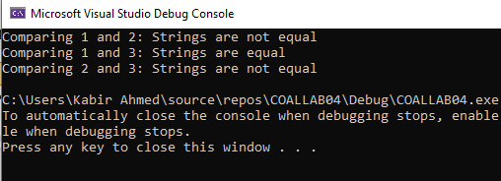
Q4
INCLUDE Irvine32.inc

.data
Str1 BYTE "Samiya Khan", 0
msgBefore BYTE "Before Reverse: ", 0
msgAfter BYTE "After Reverse: ", 0

.code
main PROC
mov edx, OFFSET msgBefore
call WriteString

mov edx, OFFSET Str1
call WriteString
call Crlf

push OFFSET Str1
call Str_Reverse

mov edx, OFFSET msgAfter
call WriteString

mov edx, OFFSET Str1
call WriteString
call Crlf

exit
main ENDP

Str_Reverse PROC
push ebp
mov ebp, esp

mov esi, [ebp+8]
mov edi, esi

FindEnd:
cmp BYTE PTR [edi], 0
je BeginReverse
inc edi
jmp FindEnd

BeginReverse:
dec edi

ReverseLoop:
cmp esi, edi
jge DoneReversing

mov al, [esi]
mov bl, [edi]

mov [esi], bl
mov [edi], al

inc esi
dec edi
jmp ReverseLoop

DoneReversing:
pop ebp
ret 4
Str_Reverse ENDP

END main

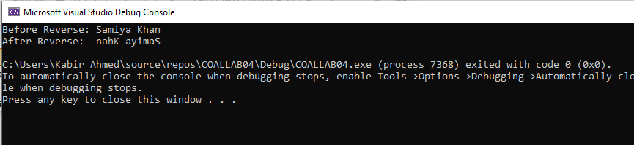
Q5
INCLUDE Irvine32.inc

.data
tableData DWORD 1, 2, 3, 4,
5, 6, 7, 8,
9, 10, 11, 12

msgHeader BYTE "Matrix Output (3 x 4):", 0

.code
main PROC

mov edx, OFFSET msgHeader
call WriteString
call Crlf

mov esi, OFFSET tableData
mov ecx, 3

rowLoopX:
mov ebx, 4

colLoopX:
mov eax, [esi]
call WriteDec
mov al, ' '
call WriteChar

add esi, 4
dec ebx
jnz colLoopX

call Crlf
loop rowLoopX

exit
main ENDP

END main

